

**TOBB UNIVERSITY OF ECONOMICS AND TECHNOLOGY**

**DEPARTMENT OF COMPUTER ENGINEERING**

**ACADEMIC RESEARCH AND ANALYSIS PORTAL**

# BİL496 Senior Design Project Report

|  |  |
| --- | --- |
| *Semester* | 2013-2014 Fall |
| *Group name* | ACADEMIC RESEARCH AND ANALYSIS PORTAL |
| *Student names and email addresses* | Gökhan GÜNEY - [st081101028@etu.edu.tr](mailto:st081101028@etu.edu.tr) |
| *Group web page* |  |
| *Advisors* | Doç. Dr. Erdoğan DOĞDU  Yrd. Doç. Dr. Ahmet Murat ÖZBAYOĞLU |

Contents

1. Introduction 3

1.1. Brief summary of this report 3

1.2. Problem Definition 3

1.3. Purpose of the Project 4

1.4. Scope of the Project 4

1.5. Overview 4

1.6. Definitions and Abbreviations 5

2. Previous Work 6

3. Requirements 8

3.1. Specific Requirements 8

a. Interface Requirements 8

b. Functional Requirements 9

c. Non-functional Requirements 9

3.2. Software System Attributes 11

4. Design 12

4.1. Data Description 12

4.2. Architectural Design 29

4.3. Website Design 30

4.4. Design Rationale 31

4.5. User Interface Design 32

*Every main button on index page has it’s own animation.* 33

5. Implementation 40

5.1. Software Implementation 40

5.2. Language Implementation 41

5.3. Algorithms 41

5.4. Program List 41

5.5. Work Load and Timeline 41

6. User Manuel 42

7. Test Results and Evaluation 45

8. Conclusion 49

9. References 50

10. Lines-of-code Table 51

# Introduction

This document is about an academic research and analysis portal project design. This document shows and explains the final details of the project and the system. In this project, my aims are to solve existing problems and design more improved web site.

## Brief summary of this report

This report explains all project aims, functions and ideas. It also shows differences between this project and other web sites. Users can also use this document to learn functions of the system that they can benefit. It explains detailed explanation about implementation, database design, parser and the system process by clarifying each requirement. It is also a good documentation or tool for investigating while improving similar projects.

## Problem Definition

In today’s world, academic researchers are quite important. Specially, technology is improving on the computer side, resources are becoming more public and open; researches are getting easy to access to details of the articles, journals and papers.

Searching is the hardest part for writing new articles. For this process finding the right material is crucial. Also, finding the related topic and analyzing it even harder and exhausting. First of all, academicians have to find the most related references or they want to find other academicians to work with similar subjects. For these reasons, searching is not enough to publish new articles, but also analyzing must be necessary for writing new articles.

Beside academic researchers, universities also start to give importance to academic researches. They want students to start using academic papers in their works and searches so it is also good for master degree students.

This Web-based project is available to everyone who wants to access the data related to their topic. It should be fast reacting system to reach the information about their interested areas.

## Purpose of the Project

In this project, my main goal is to make a usable academic research and analyze data for all users who want to make searches and analysis easily. With this project, researchers have an ability to search their topic and analyze the outcomes. They have a chance to filter and select the related parts of the topic. This way, this project save their precious time and get the information without making an effort.

In addition to these properties, the system shows analysis of data so; users have information about research area that they are dealing with. Users can see popular studies and their percentage so that they can draw a correct path for their career. It is very helpful to find unsought topics that have to focus on. System helps to make a list that shows the most popular studies and academicians, and also in which city, country or institution researches published their articles.

## Scope of the Project

There are already research portals but they are not that large scaled. They cannot make search as detailed as this project. Users use this portal when they are looking for an academic article; searching by author name, city, county, subject, category and institution. Users can find their search with auto complete tool easily, it is also good for remember or recognize other areas. They can associate topics and increase the number of search fields with different options. Researches can take notice of current topics with their researches; so they find new areas to focus on.

## Overview

This document is a system requirement specification for the Academic Research and Analysis Portal. This document defines the new point of views to the system and user requirements.

To determines the general outlines of the system I examine it in topics as:

* Introduction; presentation to the system, purpose, general view to the system.
* Previous studies that similar to this project
* Specific Requirements; system requirements (interfaces), technical properties, constraints, user characteristics and more detailed features of the system.
* Data Model and Design Description; relationships, data model, system behavior
* Implementation steps
* Create a user’s manual to help users to explain the system
* Explain test and evaluation steps and their results

## Definitions and Abbreviations

PT: Publication Type

AU: Author

AF: Author Full name

TI: Title

SO: Subject

LA: Language

DT: Document Type

DE: Author Keywords

ID: Keywords Plus

AB: Abstract

C1: Department, School

RP: Reprint Address

RI: Index

CR: Cited References

NR: Number

TC: Time Cited

PU: Publisher

PA: Publisher Address

SN: ISSN

J9: Interest Area

JI: Interest Area

PD: Publication Date

PY: Publication Year

VL: Volume

IS: Issue

DI: DOI

PG: Pages

WC: Web of Science Categories

SC: Research Areas

GA: IDS Number

UT: Accession Number

ER: End of Record

EF: End of File

CT: Course Tools

CY: Conference Year

CL: Conference Location

SP: Special Publication

HO: History Of

EM: Email

FU: Fund

FX: Fund Detail

DB: Data Base

CSS: Cascading Style Sheets

PHP: Hypertext Preprocessor

CPU: Central Processing Unit

GPU: Graphics Processing Unit

# Previous Work

When we look and examine other web sites with every detail, we only find search tools. These are very simple and undetailed tools. They do not help researchers to draw a path through their thoughts, and they do not give a clue to where they should start to search about their subjects. Researchers are going to lost in long lists and lose their time while they are looking at these basic results of lists.

In some web sites and portals, they have some searching feature for researchers. However, when the user wants to search something these web sites are not enough. Within massive database systems, users can only search for particular fields like topic, keywords, ISBN, year etc. but nothing fancy like analysis tools. Users need a search portal which is not only about general information or accept entrances for more specific values, but also want to see relations and make hierarchical searches.

For this project, I analyzed some web sites and see that they are not enough for user. I make a decision to design and shape my own project. For this thought, I have to use database effectively and create more complex queries to get relations and more specified data. So, users can reach aggregated data in order to search separated sites.

Besides these [deficiencies](http://tureng.com/search/deficiencies), their graphical user interface is ugly. For me, search interfaces should be not fatiguing. I design familiar interface but has much more beautiful color theme.

Below, some images from other web sites are found:

**Table1**: Science Direct Search Tool

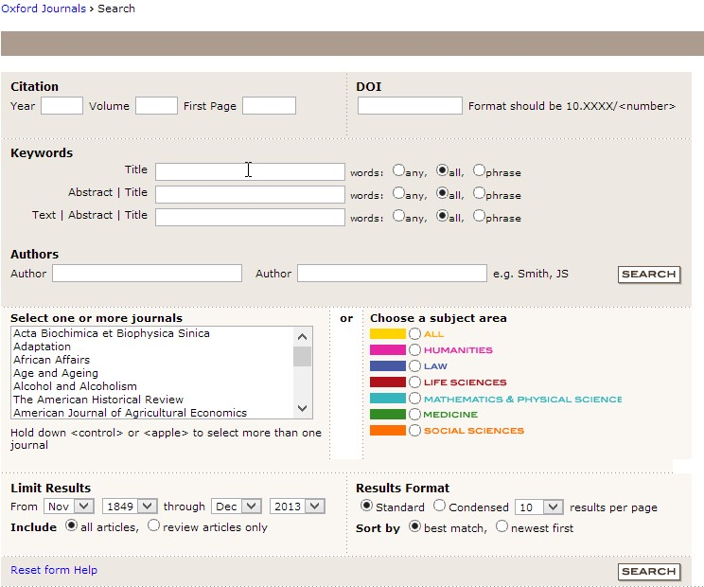

**Table2**: Oxford Search Tool



**Table3:** GO Articles Search Tool

# 3. Requirements

## 3.1. Specific Requirements

### a. Interface Requirements

For this project:

* I need data from different academic sources. Data have to be detailed so the results are proper.
* For parsing I use Java programming
* To write a Java code and compile it I use Eclipse KEPLER.
* For the database design I use MySQL Workbench
* For the portal’s design and GUI; Adobe Dreamweaver CS 6 is used (for CSS coding).
* For the portal’s coding Adobe Dreamweaver CS 6 is used (for PHP coding).
* Few more tools can be used for analysis part.
* All codes are written on my personal laptop so Windows 8 64-Bit Operating System is the platform

### b. Functional Requirements

Functional requirements are important because without them the system could not carry out its functions.

* + Users have to enter values into the fields what they want to search. Users should not leave the field empty. Otherwise system is not work properly.
  + The field name (author, subject, city, country, institution, and category) that users are searching for should match with the fields of database otherwise the search cannot give a result.

### c. Non-functional Requirements

* + 1. **Performance Requirements**

Performance is quite important for this project:

* Speed has the prime importance.
* Time is limited so, low latency background tasks should work properly.
* Information from database should be getting pretty fast to make researchers job fast
  + 1. **Design Constraints**

For this project, I do not have any design constraints I have to design this system fast-responsive but for this matter it does not count as design constraint.

**Hardware Constraints**

* In this project, users have to have Windows XP, Windows Vista, Windows 7, and Windows 8 Operating System. This project work on Mac and Android Operating Systems. I develop this project on Windows 8 64-Bit Operating System
* Users have to use 1.4GHz Intel®, Pentium® 4 or other advanced CPU to adapt new operating system easily and reach the highest and the fastest performance.
* 16 GB (32bit) or 20GB (64 bit) available disk place is needed for operating system.
* 1GB (32 bit) or 2GB (64bit) RAM, recommended, is necessary for my project.
* User has to access network via server.
* Users must have internet connection.

**Software Constraints**

* Software should be modularized into classes by using object-oriented design principles.
* In this project, the application needs to be programmed in PHP and HTML language with SQL queries.
* Users have to access data all the time. Therefore, database must be connected to the system.
* Web site design must allow users to fill field areas or choose interested topics.
* Repeated and inexplicit data have to be selected and eliminated to build an efficient database.
* Users have to enter values to the fields that they are looking for correctly.
* For database, tables have to have Primary Key Constraint and this attribute have to be unique to determine differences between data, Unique Constraint.
* Also in database, programmer has to use Foreign Key Constraint to make relations between tables for multiple-lined topic, like abstraction.

**Time Constraints**

* The database should work properly without giving any errors in short time.
* The basic queries should work correctly in short time.

**Security Constraints**

* This portal is opened to the every end-user.
* Server’s security will be design by server side.
* The codes of this project is only be modified by the project members.

## 3.2. Software System Attributes

* + - * 1. **Usability**

Users’ experience is at various levels so, software system has to be designed user-centered:

* Graphical User Interface should be easy and understandable to work on it.
* Graphical User Interface’s colors should be picked carefully so users can use this system without getting any fatigue.
* System should hide its complexity behind the Graphical User Interface so the users can use this system with ease.
  + - * 1. **Reliability**
* Results from queries must be reliable.
* Search should not take too long time. It should be time efficient.
* System should response in 5 seconds. (It can vary with connection speed of the user). Since I use local network it should not be a problem.
  + - * 1. **Availability**
* Server must be accessible of all the time.
* System must be backed up.
  + - * 1. **Security**
* Data must be permanent.
* Security must be designed by the server-side.
  + - * 1. **Maintainability**
* System’s code should be updatable by authorized people.
* To have better performance system should be written with its comments so further changes can be happen easily.
  + - * 1. **Portability**
* System should be work on every operating system with a browser and internet connection.
* Since system does not have any installation file it is highly portable for the use.
* Users can access in every environment which has internet connection.

# 4. Design

## 4.1. Data Description

All values in all tables in the database are the most important objects to give a form to this project. These data shows object view of related tables. By this relation of grouping tables and other assigned values like Primary Keys, Foreign Keys; I can combine topics and use database easily to find answers.

* + Indexing is for multiple-lined columns.
  + I parse data that found in cells, because each of data has to be used for analyzing and used for searching parts
  + I separate huge database to get information quickly and see the relations between all data.
  + I use ID to join tables without repeating cells.

Data base design is found at the following:

Drop queries for the tables if there is table exists:

drop table `bil496`.`institutions`;

drop table `bil496`.`authors`;

drop table `bil496`.`subjects`;

drop table `bil496`.`references`;

drop table `bil496`.`categories`;

drop table `bil496`.`countries`;

drop table `bil496`.`cities`;

drop table `bil496`.`titles`;

drop table `bil496`.`abstracts`;

drop table `bil496`.`aas`;

drop table `bil496`.`asr`;

drop table `bil496`.`aac`;

drop table `bil496`.`ais`;

drop table `bil496`.`aic`;

drop table `bil496`.`auCoAu`;

drop table `bil496`.`instAnalysis`;

drop table `bil496`.`subAnalysis`;

drop table `bil496`.`auAnalysis`;

drop table `bil496`.`catAnalysis`;

drop table `bil496`.`coAnalysis`;

drop table `bil496`.`ciAnalysis`;

Create queries for the tables:

**CREATE TABLE `bil496`.`institutions`** (

`IID` INT NOT NULL AUTO_INCREMENT ,

`IName` TEXT

NOT NULL ,

`ICityID` VARCHAR

(45) NULL ,

`ICountryID` VARCHAR(45) NULL ,

`TCount` INT

NULL ,

`IMore1` TEXT NULL ,

`IMore2` TEXT NULL ,

PRIMARY KEY (`IID`) ,

INDEX `IName` (`IName`(20) ASC) );

**CREATE TABLE `bil496`.`authors`** (

`AUID` INT NOT NULL

AUTO_INCREMENT,

`AUAddressID` INT

NULL ,

`AUName` TEXT NOT NULL ,

`AUFullAddress` TEXT NULL ,

`TCount` INT NULL ,

`AUMore1` TEXT NULL ,

`AUMore2` TEXT NULL ,

PRIMARY KEY (`AUID`),

INDEX `AUName` (`AUName`(30) ASC));

**CREATE TABLE `bil496`.`subjects`** (

`SID` INT NOT NULL AUTO_INCREMENT,

`SName` TEXT NULL ,

`TCount` INT NULL ,

PRIMARY KEY (`SID`), INDEX `SName` (`SName`(30) ASC));

**CREATE TABLE `bil496`.`categories`** (

`CID` INT NOT NULL AUTO_INCREMENT,

`CName` TEXT

NULL ,

`TCount` INT NULL ,

PRIMARY KEY (`CID`), INDEX `CName` (`CName`(30) ASC));

**CREATE TABLE `bil496`.`references`** (

`RID` INT NOT NULL AUTO_INCREMENT ,

`RName` TEXT

NULL ,

`RDOI` VARCHAR(200), `RAID` INT NULL ,PRIMARY KEY (`RID`),INDEX `RName` (`RName`(50) ASC) );

**CREATE TABLE `bil496`.`countries`** (

`CoID` INT NOT NULL AUTO_INCREMENT ,

`CoName` TEXT

NULL ,

`TCount` INT ,PRIMARY KEY (`CoID`),INDEX `CoName` (`CoName`(20) ASC) );

**CREATE TABLE `bil496`.`cities`** (

`CiID` INT NOT NULL AUTO_INCREMENT ,

`CiName` TEXT

NULL ,

`TCount` INT ,PRIMARY KEY (`CiID`),INDEX `CiName` (`CiName`(20) ASC) );

**CREATE TABLE `bil496`.`titles`** (

`AID` INT NOT NULL,

`TI` TEXT

NULL, `PY` INT

NULL ,PRIMARY KEY (`AID`) ,INDEX `TI` (`TI`(20) ASC) );

CREATE TABLE `bil496`.`abstracts` (

`AID` INT NOT NULL,

`AB` TEXT

NULL ,

PRIMARY KEY (`AID`) ,INDEX `AB` (`AB`(20) ASC) );

**CREATE TABLE `bil496`.`aas`** (

`AID` INT NOT NULL ,

`AUID` INT NOT NULL ,

`SID` INT NOT

NULL ,INDEX `AID` (`AID` ASC),INDEX `SID` (`SID` ASC),INDEX `AUID` (`AUID` ASC))

COMMENT = 'Article Author Subject Connection Table';

**CREATE**

**TABLE `bil496`.`asr`** (

`AID` INT NOT NULL ,

`SID` INT NOT NULL ,

`RID` INT NOT

NULL ,INDEX `AID` (`AID` ASC) ,INDEX `SID` (`SID` ASC) ,INDEX `RID` (`RID` ASC))

COMMENT = 'Article Subject Reference Connection Table';

**CREATE TABLE `bil496`.`aac`** (

`AID` INT NOT NULL ,

`AUID` INT NOT NULL ,

`CID` INT NOT

NULL ,INDEX `AID` (`AID` ASC))

COMMENT = 'Author Category Connection Table';

**CREATE TABLE `bil496`.`ais`** (

`AID` INT NOT NULL ,

`IID` INT NOT NULL ,

`SID` INT NOT

NULL,INDEX `AID` (`AID` ASC))

COMMENT = 'Article Institution Subject Connection Table';

**CREATE TABLE `bil496`.`aic`** (

`AID` INT

NOT NULL ,

`IID` INT NOT NULL ,

`CID` INT NOT

NULL,INDEX `AID` (`AID` ASC))

COMMENT = 'Article Institution Category Connection Table';

**CREATE TABLE `bil496`.`auCoAu`** (

`AUID` INT NOT NULL ,

`CoAUID` INT NOT NULL,Primary KEY (`AUID`,`CoAUID`) )

COMMENT = 'Authors and CoAuthors Connection Table';

**CREATE TABLE `bil496`.`instAnalysis`** (

`IID` INT NOT NULL ,

`PY` INT NOT NULL ,`TCount` INT NOT NULL,INDEX `IID` (`IID` ASC) )

COMMENT = 'How many records have the institutions';

**CREATE TABLE `bil496`.`subAnalysis`** (

`SID` INT NOT NULL ,

`PY` INT NOT NULL ,

`TCount`

INT NOT NULL ,INDEX `SID` (`SID` ASC))

COMMENT = 'How many subjects in years';

**CREATE TABLE `bil496`.`auAnalysis`** (

`AUID` INT NOT NULL ,

`PY` INT NOT NULL ,

`TCount`

INT NOT NULL, INDEX `AUID` (`AUID` ASC))

COMMENT = 'How many records have the

authors';

**CREATE TABLE `bil496`.`catAnalysis`** (

`CID` INT NOT NULL ,

`PY` INT NOT NULL ,

`TCount`

INT NOT NULL,INDEX `CID` (`CID` ASC) )

COMMENT = 'How many categories in years';

**CREATE TABLE `bil496`.`coAnalysis`** (

`CoID` INT NOT NULL ,

`PY` INT NOT NULL ,

`TCount` INT NOT NULL ,INDEX `CoID` (`CoID` ASC))

COMMENT = 'How many records have the countries';

**CREATE TABLE `bil496`.`ciAnalysis`** (

`CiID` INT

NOT NULL ,

`PY` INT NOT NULL ,

`TCount`

INT NOT NULL ,INDEX `CiID` (`CiID` ASC))

COMMENT = 'How many records have the cities';

**Here are the screen shots from main tables:**

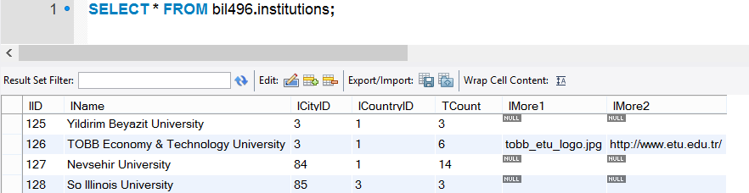

**Table 4:** Picture ofDatabase Design #1

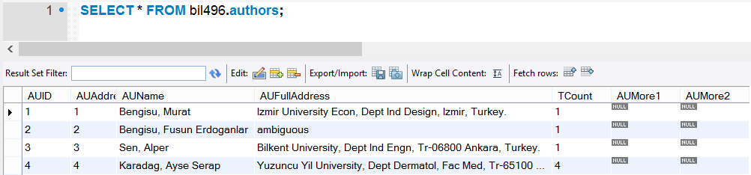

**Table 5:** Picture ofDatabase Design #2

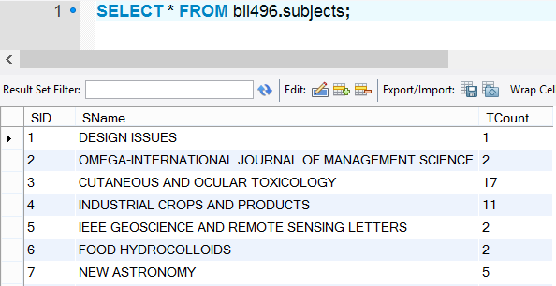

**Table 6:** Picture ofDatabase Design #3

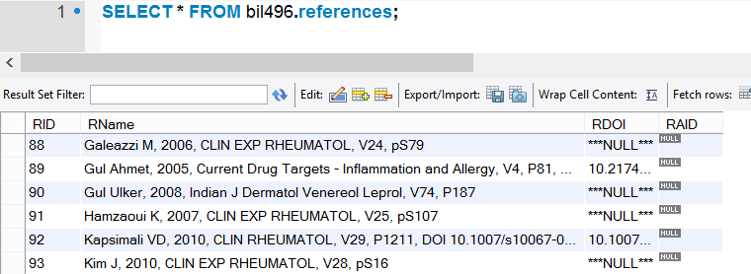

**Table 7:** Picture ofDatabase Design #4

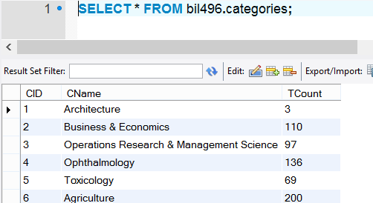

**Table 8:** Picture ofDatabase Design #5

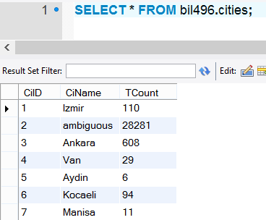

**Table 9:** Picture ofDatabase Design #6

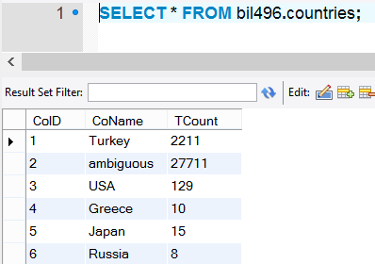

**Table 10:** Picture ofDatabase Design #7

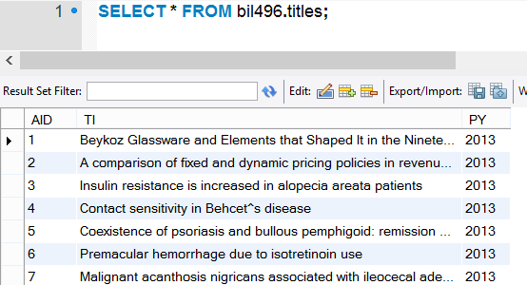

**Table 11:** Picture ofDatabase Design #8

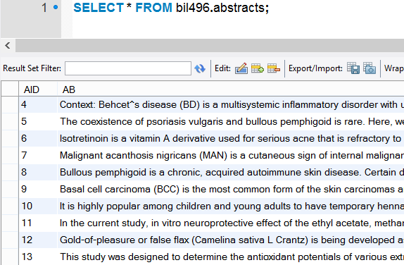

**Table 12:** Picture ofDatabase Design #9

**Here are the screen shots from co-tables:**

Those tables create a bridge with main tables. For example: AAS table means Article-Author-Subject. With help of these tables and main table, system can determinate which author included in which article and which article written in which subject. Every co-table has its comment in it with its creation code.

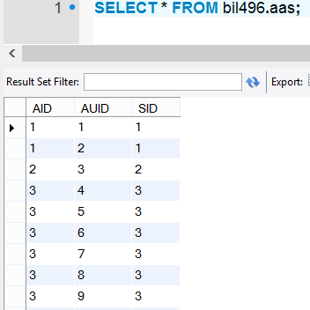

**Table 13:** Picture ofDatabase Design #10

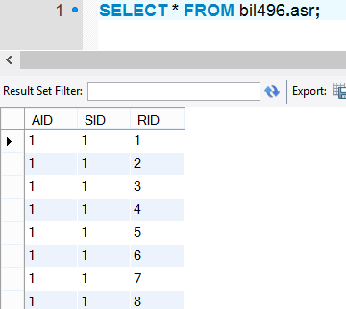

**Table 14:** Picture ofDatabase Design #11

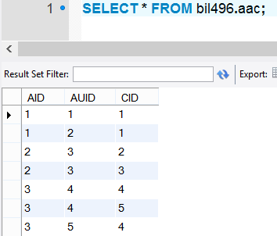

**Table 15:** Picture ofDatabase Design #12

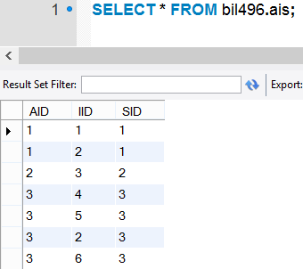

**Table 16:** Picture ofDatabase Design #13

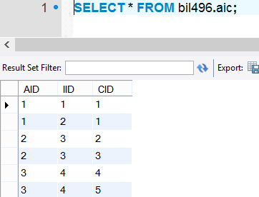

**Table 17:** Picture ofDatabase Design #14

Aucoau co-table work as bridge with which author write an article with which authors. It has every connection between authors not only the article based. It has all data for every article. For example, If Author 1 wrote article with author 2 in a article but then author 1 wrote 1 article with author 50; that means there will be 4 records:

* 1,2
* 2,1
* 1,50
* 50,1

With this table system can find Author 1 has 2 co-authors 2 and 50.

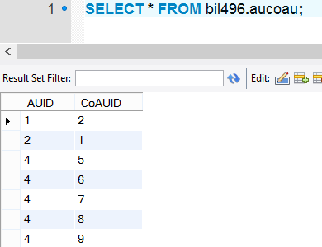

**Table 18:** Picture ofDatabase Design #15

**After this part there are analysis tables:**

All those analysis tables has created for their related fields. For example instanalysis created for institutions and their analysis. All analysis tables have 3 columns. First column has the id of institution, author, city, country, subject or category. Second column is publication year gathered from the article and third column is about total count of the field.

For example AUID = 1, PY=2013 and TCount =1

That means Author 1 has 1 article in 2013.

With the help of Authors table: Bengisu, Murat has 1 article in 2013.

Again, like auanalysis table catanalysis has the same structure.

For example CID = 5 , PY = 2013, TCount = 26

That means Category 5 has 26 article in 2013.

With the help of Categories table in 2013 there are 26 articles written in Toxicology.

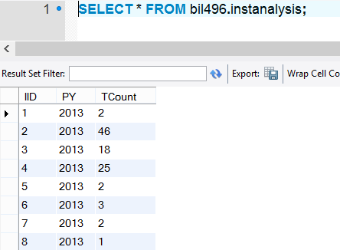

**Table 19:** Picture ofDatabase Design #16

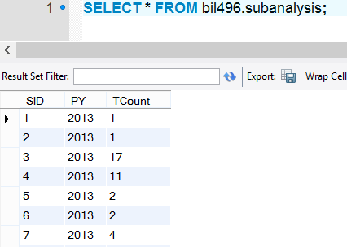

**Table 20:** Picture ofDatabase Design #17

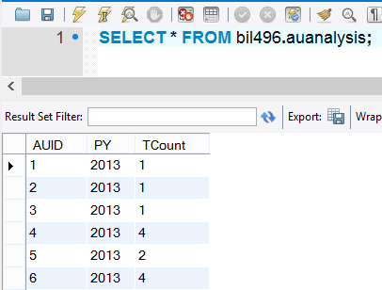

**Table 21:** Picture ofDatabase Design #18

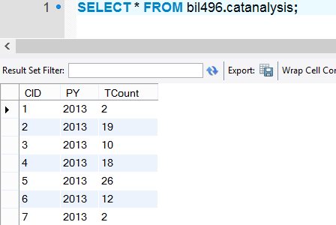

**Table 22:** Picture ofDatabase Design #19

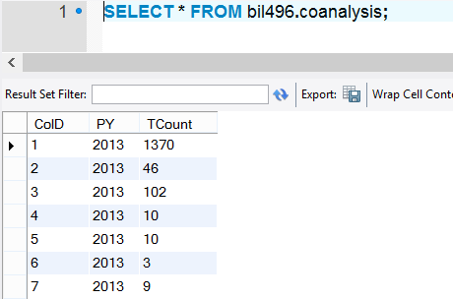

**Table 23:** Picture ofDatabase Design #20

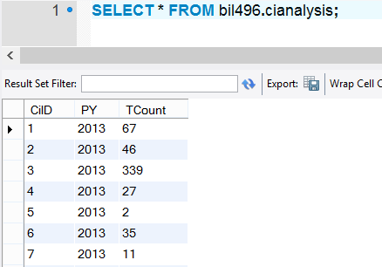

**Table 24:** Picture ofDatabase Design #21

**Data Dictionary**

|  |  |  |
| --- | --- | --- |
| FIELD NAME | DATA TYPE | DESCRIPTION |
| AU  (Can be omitted because of AF) | Char | Author Name |
| PT | Char | Publication Type |
| AF | Char | Author Full Name |
| TI | Char | Title |
| SO | Char | Subject |
| LA | Char | Language |
| DT | Char | Document Type |
| CT | Char | Course Tools |
| CY | Date | Conference Year |
| CL | Char | Conference Location |
| SP | Char | Special Publication |
| DE | Char | Author Keywords |
| HO | Char | History Of |
| ID | Text | Keyword Plus |
| AB | Text | Abstract |
| C1 | Text | Department School |
| RP | Text | Reprint Address |
| EM | Char | Email |
| RI | Char | Index |
| FU | Text | Fund |
| FX | Text | Fund Detail |
| CR | Text | Cited References |
| NR | Int | Number |
| TC | Int | Time Cited |
| PU | Text | Publisher |
| PA | Text | Publisher Address |
| SN | Char | ISSN |
| J9 | Text | Interest Area |
| JI | Text | Interest Area |
| PD | Char | Publication Date |
| PY | Date | Publication Year |
| VL | Int | Volume |
| IS | Int | Issue |
| DI | Char | DOI |
| PG | Int | Pages |
| WC | Text | Web of Science Category |
| SC | Text | Research Areas |
| GA | Char | IDS Number |
| UT | Char | Accession Number |

**Table 25**: Data Dictionary

***Data Type*:** I have text, char, integer, date etc. data types.

***Field Size:*** I have fields with maximum capacity for long information and default field capacity for other information.

There is additional data dictionary for the database:

I use data dictionary to name database columns. There are columns named AID and ArticleID both means Article ID, AUID means Author ID, IID means Institution ID, CID means Category ID, CiID means City ID, CoID means Country ID and RID is Reference ID.

All information and column names shortened like this. Also, almost every database table has its own comment so this makes tables easily understandable.

## C:\Users\user\Dropbox\MINE SYNC\School\BİTİRME PROJESİ\system-interface-web.png4.2. Architectural Design

**Table 26:** Architecture Design

* This architectural design provides consistent information to all users for reaching the same database.
* Users use web-based graphical user interface. And all of the information will be stored in the huge database. When users use web interface, system use their keywords to scan database. The system turns result sets.
* User can analyze the records.
* This architecture is client-server system.

## 4.3. Website Design

* This web-based is designed with text field interfaces.
* System starts when researcher enters keywords to the fields.
* System gets keywords and puts them into queries for the SQL.
* Data is exported from the database which is suitable to keywords.
* To make the search quicker and understandable there are many titles, like author, subject, city, country, institution and category.
* Users can fill all text fields with auto-complete property.
* Text fields can be clickable, so that users can see the detailed information about this data.
* If users want to search about specific subject, they should choose “Subject” area.
* In “Subject” part, users can find total counts of relevant subject, DOI numbers and cited references.
* If users want to search about author, they should choose “Author” area.
* In “Author” part, users reach authors’ profile.
* In this profile, users can see the address, the institution, the city and the country of the researcher.
* They can also obtain information about authors’ co-authors. It helps researchers when they want to work with other researchers for their interested area.
* And also, they can find authors’ articles and how many articles are written by related author.
* If users want to search address they should choose “City” or “Country” areas.
* In these areas, they find institutions that take place in specified query.
* If users want to search institution they should choose “Institution” area.
* Institution search guides users to the institution profile page.
* In this page, users can find institutions’ authors and which categories they wrote about, and all articles published in this institution.
* If users want to search about category they should choose “Category” area.
* By this searching, users learn the total count of articles written about and their information.
* For Analyze part, the user can enter 1 to 5 fields with start and end years.
* The user has not to specify years, the system gives default values for these fields. For this part it is 1900 to 2013.
* The user can see distribution of total results of authors, subjects, countries, cities, categories and institutions according to the given years
* Expert parts includes two area; Expert Author and Expert Domain
* Expert Author shows the list of most expert authors about selected subject
* Expert Domain shows the most expert institution that published the most articles about selected subject.
* And Top List part gives the best authors, subjects, categories, cities, countries and institutions. This rating is determined by the maximum total counts of each topic.

**Table 27:** Picture of Main Page

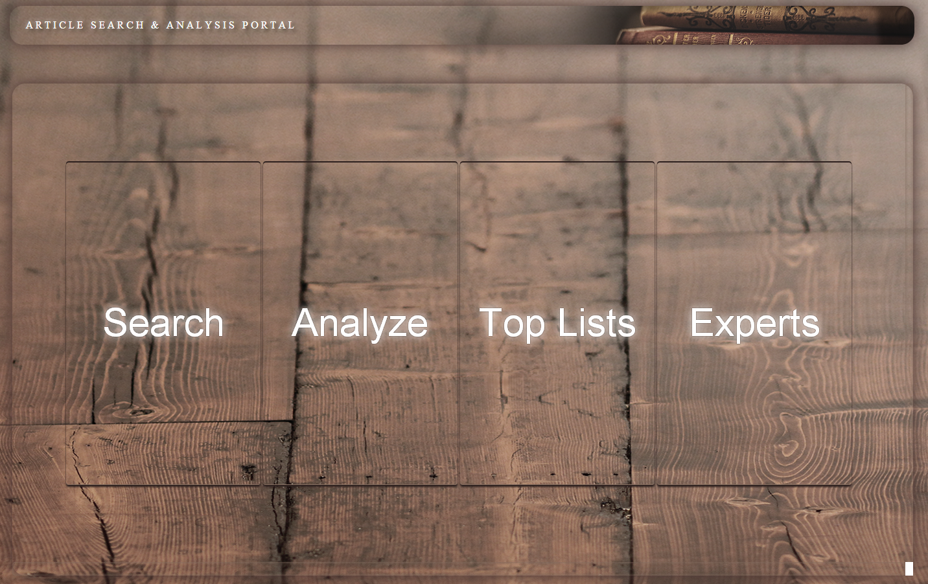

## 4.4. Design Rationale

Project’s design is like model-view-controller design. Also known as MVC.

* The view is the web based interface.
* Controller transforms data into Model.
* Model shows the results on the View part again.

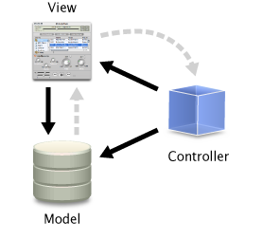

**Table 28:** Design Model

## 

## 4.5. User Interface Design

Graphical user interface is made with PHP coding language. There are labels for every text field. The user can choose “Search”, Analyze”, “Experts” or “Top Lists”. By searching tools, the user can get information about authors, subjects, city or country to get address, institutions or categories. Every search part guides users to the profile pages that include detailed information. The user can find list of all data related with topic. If data has more instruction, it can be clickable. And also, “Analyze” part provides that the user sees current topics of these years. It helps researches to find new subjects to focus on and todays’ interested areas. They can find popular researchers to work with or seek advices of other researchers. They can see institutions that published more articles and find their cities and countries. This information also helps to determine future careers. The users can enter maximum 5 search topics for analyzing and comparing data. They can limit analyzing data by specifying start and end years. “Expert” part includes two analyze results. Firstly, “Expert Author” shows researchers who write most articles on a given subject. Secondly “Expert Domain” shows institutions that dwell on a given subject. “Top List” provides quick look to see the top subjects, authors, cities, countries, institutions and categories. If they want to see more detailed part, they can click fields as they do in other pages.

Graphical presentation provides user friendly website design. It is more useful to see the result without spend many times to learn website tools. Also users reach the information step by step, if they want they can go back to the previous page. In addition every parts; search, analyze, expert, top list; have their navigation label to provides easy and quick switching between pages. To compare with other websites, this project is more colorful and more appealing to the user’s eye. Images are also suitable with subjects.

# 



# Table 29: Picture of Search Part#1

# *Every main button on index page has it’s own animation.*

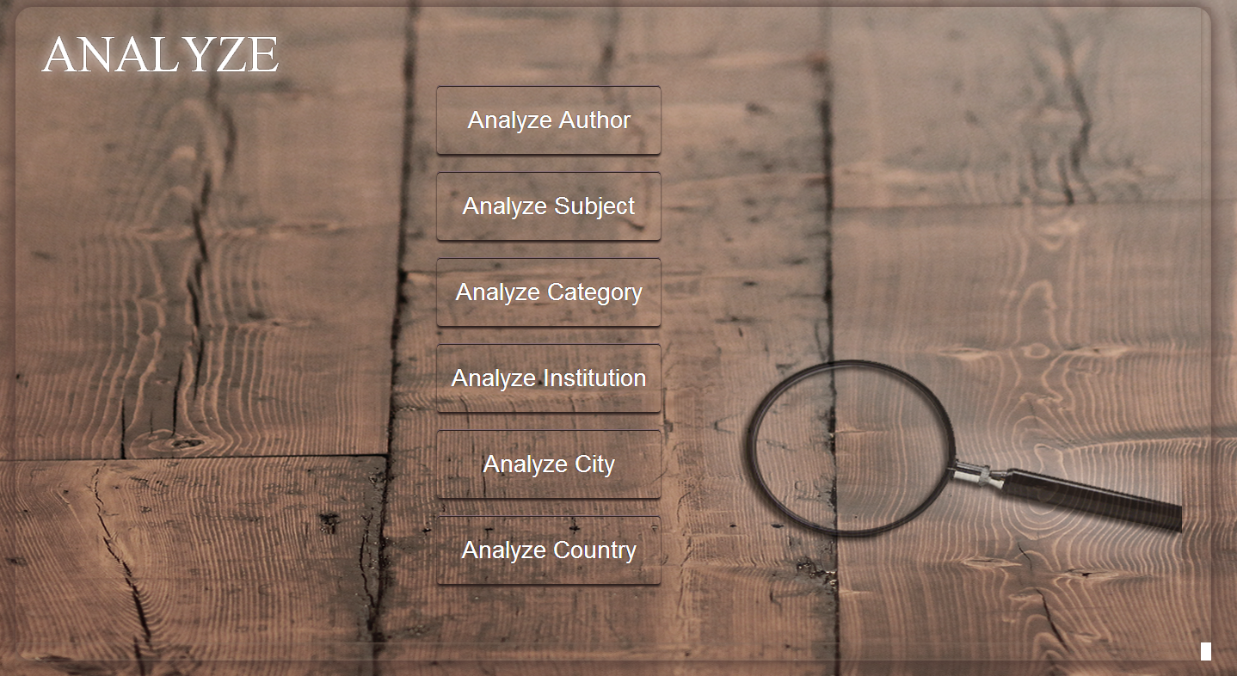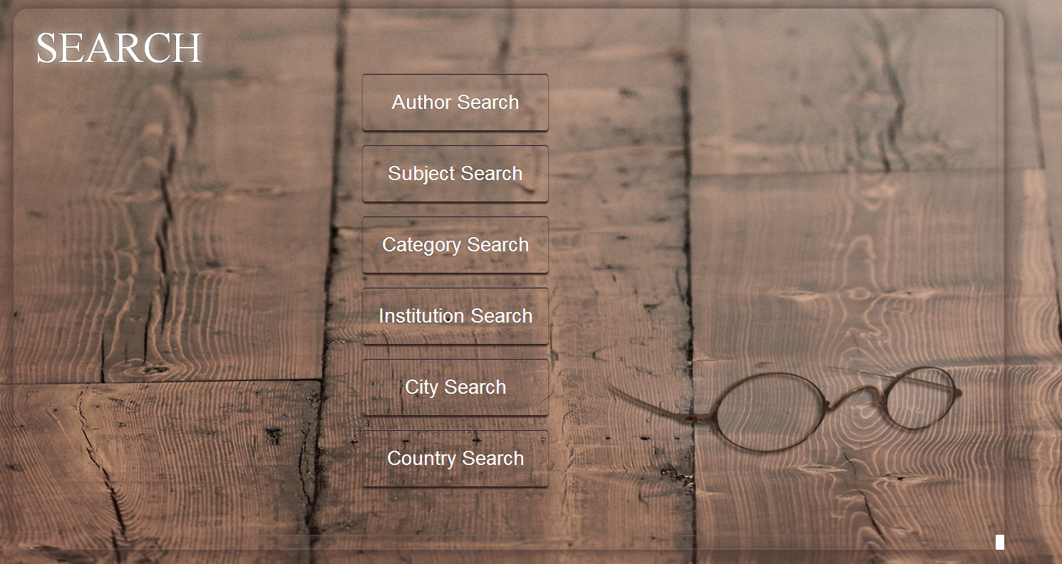

# Table 30: Picture of Search Part#2

# Table 31: Picture of Analyze Part

# Table 32: Picture of Top List Part

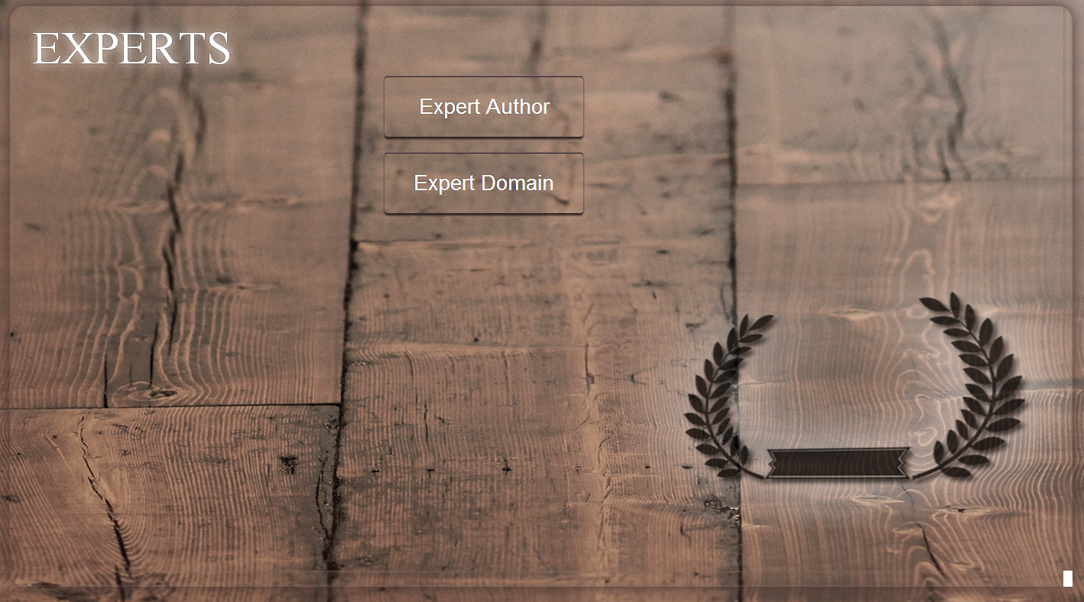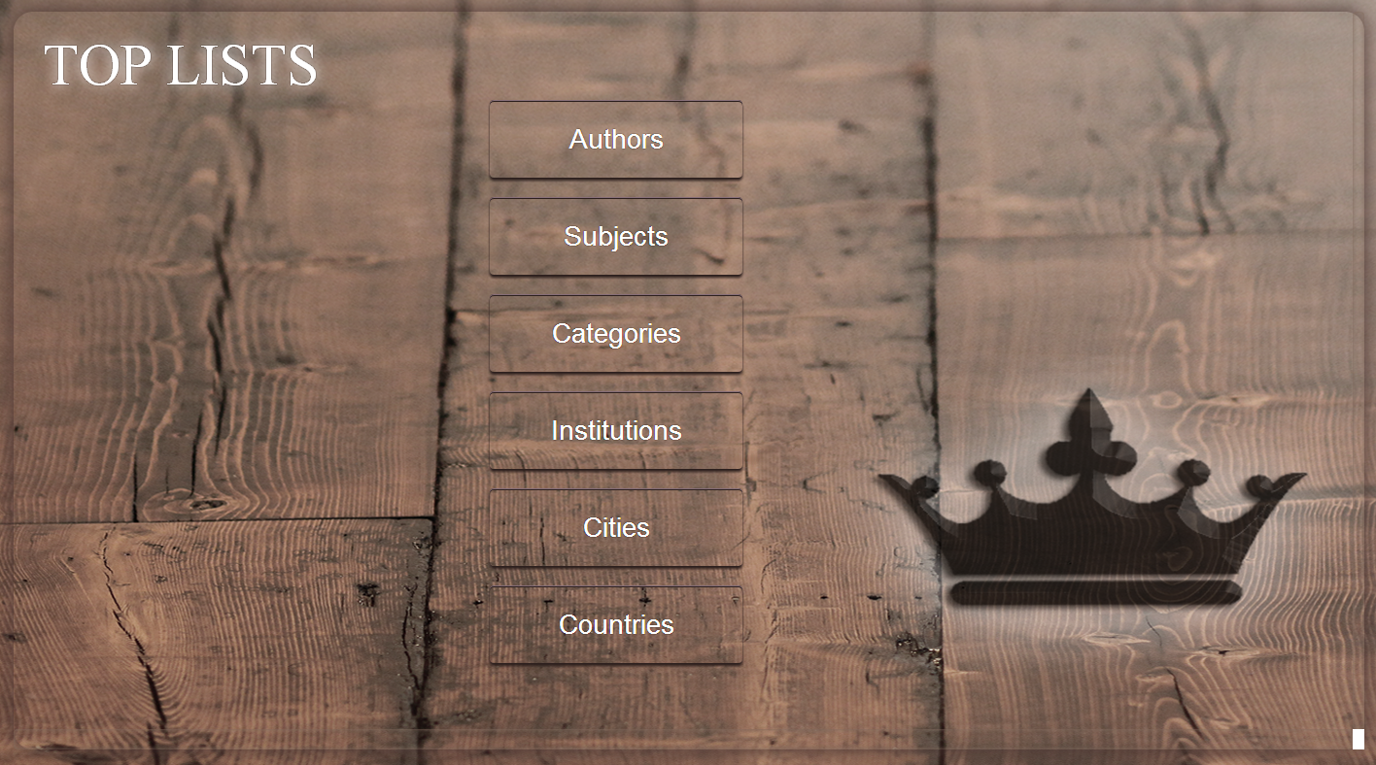

# Table 33: Picture of Experts Part

# Table 34: Picture of Search Tool#1

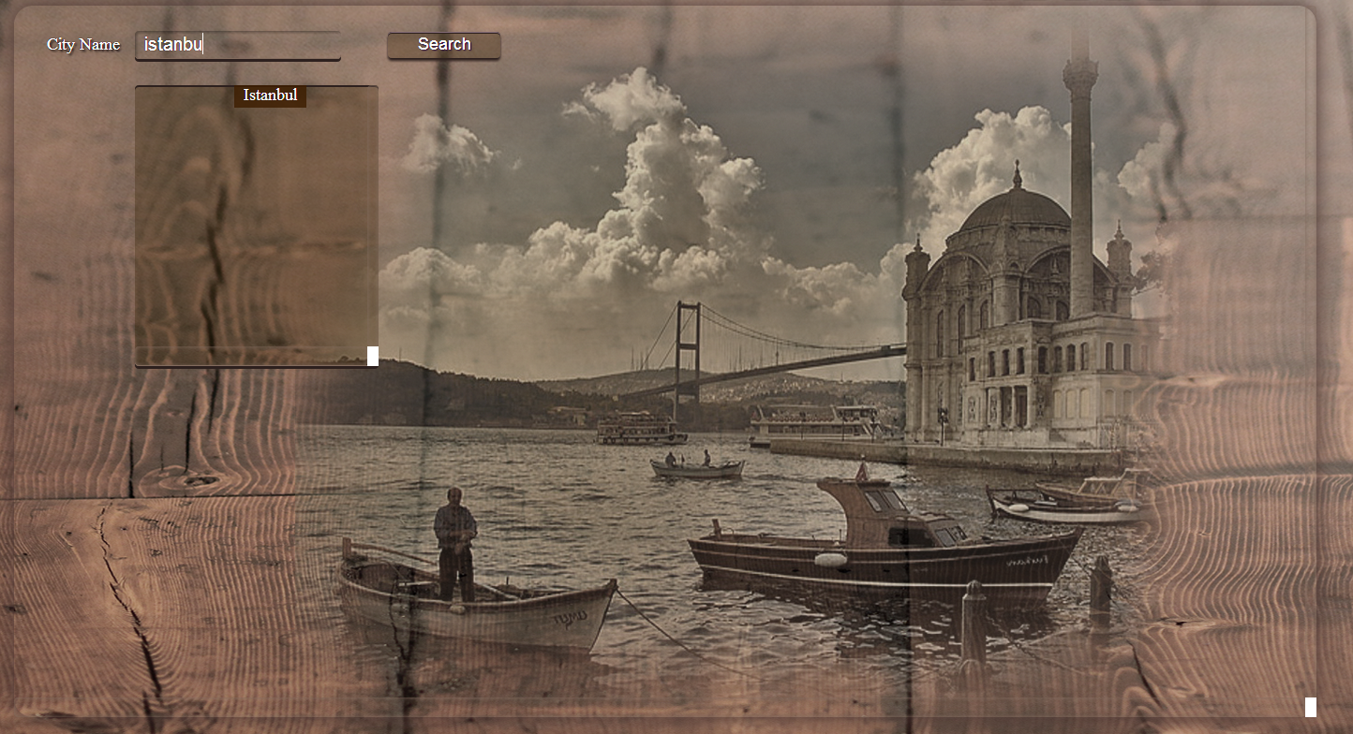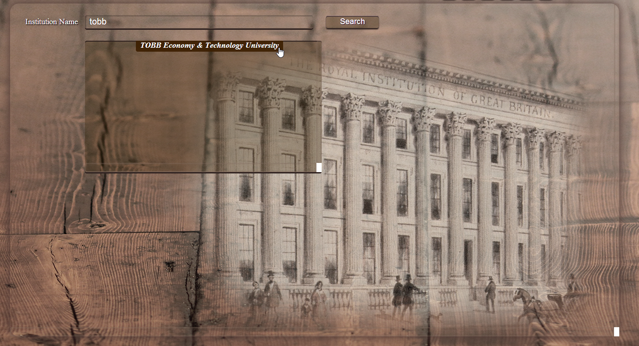

# Table 35: Picture of Search Tool#2



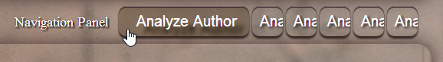

**Table 36:** Picture of Navigation Panel

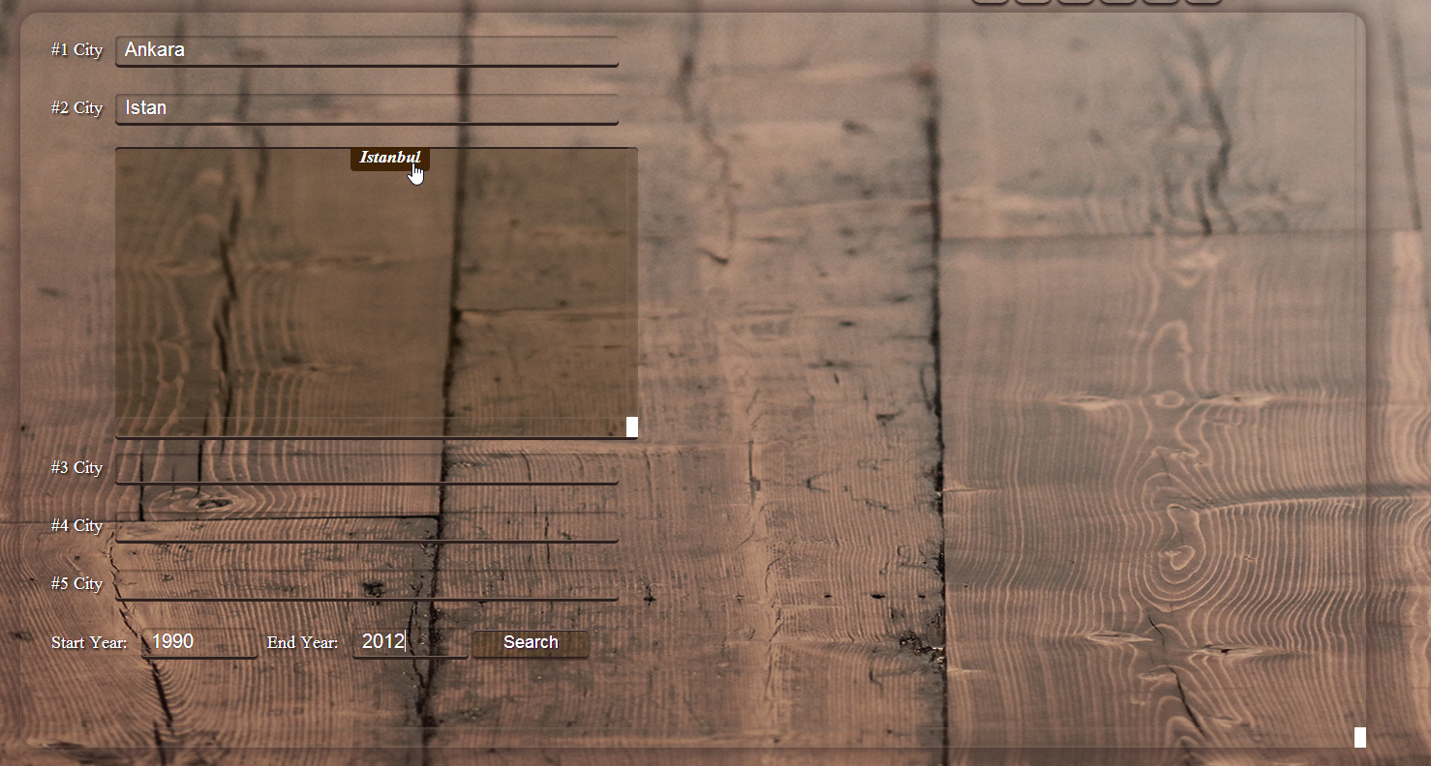

# Table 37: Picture of Analyze Tool

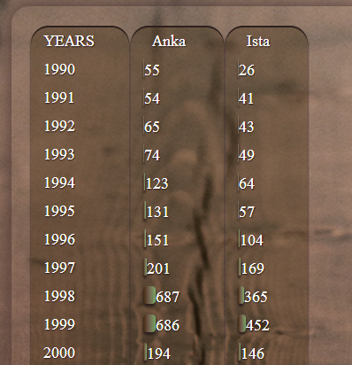

# Table 38: Picture of Analyze Results

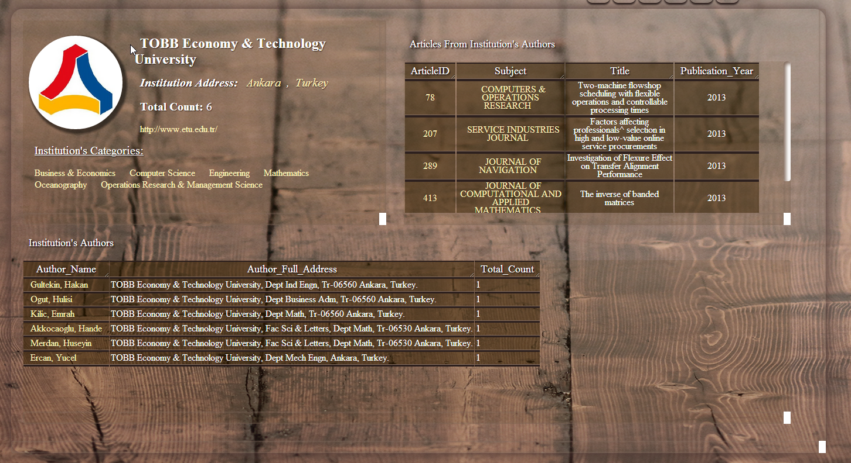

# Table 39: Picture of Institution Profile Page

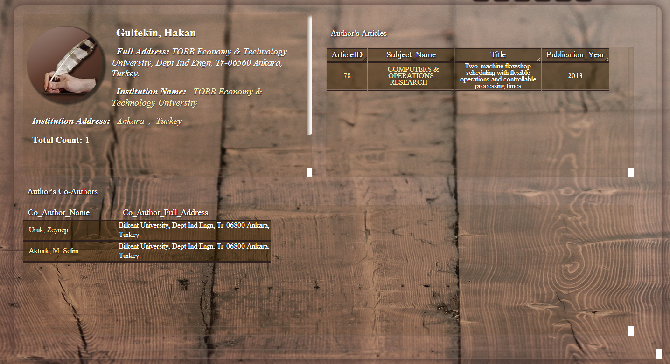

# Table 40: Picture of Author Profile Page

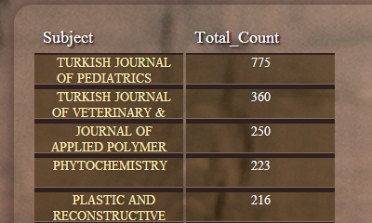

# Table 41: Picture of Subject Results

By the light of the sceen shots you can understand the system and how it works. Screen shots only show a little part of the project.

# 5. Implementation

This project is done by me so the team is just me as a member I do all the work.

I designed and developed the whole project by myself. If we look the project implementation design steps at high level;

* Parser done first.
* Database design done with parser because data base design is related to parsing.
* To make an analysis, analysis tables are created in database while parsing and separating huge data.
* And also with small data, I test the queries and their results.
* Testing is also important to give reliable results to users
* While the parser code is parsing all data, I make the php pages and css site.

There are 3 java parsers in this project. First one is parsed from html files to main table.

Second one trimmed all unnecessary information from main table and put them to table called “real”.

Third java class parsed, corrected and put all refined data to tables (which I stated in database design with screen shots and database design codes).

All these parsing processes are the heart of the project and after java I developed all PHP and CSS codes in Dreamweaver.

innoDB engine used for every table in database.

## 5.1. Software Implementation

Software design is made by Gökhan Güney. Also, almost every line of code developed by Gökhan Güney.

The software has 2 parts. First one is the parsing part. For this part, only Java is used, developed and compiled in Eclipse. Second part is the web-page part. For this part PHP, HTML, Java Script, CSS, MYSQL Workbench and XAMPP server is used.

More information will be given in the Lines-of-code table.

## 

## 5.2. **Language Implementation**

As I stated in Implementation part I used Java for parsing from html to database. Then I use CSS, HTML, PHP, JAVASCRIPT languages to design the GUI and SQL query results.

## 5.3. Algorithms

In this project, I write my own codes. There aren’t any special algorithms used for this project. However, design of this system is based on ids and indexes on tables so that makes system quite fast. Also, innoDB engine is used for all tables because of supporting all large tables.

## 5.4. Program List

* Find the existing web site and find their deficiencies
* Analyzing project requirements
* Parsing data
* Management of database
* Design tables of database
* Transfer data to database
* Design web site
* Overview project according to the feedbacks
* Test tools and project performance
* Write final report of project
* Prepare presentation

## 5.5. Work Load and Timeline

I use Waterfall model to make this project. I put some functions to the project as time goes by. I choose Waterfall model because new ideas and function can be added. As I add these functions, I have to change database design and parser to get and correct data.

|  |  |  |  |  |  |
| --- | --- | --- | --- | --- | --- |
| Data examination. | SRS | SDD | First Demo | Last Demo to Supervisors | Final report and final demo. |
| First week of the project |  |  |  |  |  |
|  | 11.10.2013 |  |  |  |  |
|  |  | 11.10.2013 |  |  |  |
|  |  |  | 05.11.2013 |  |  |
|  |  |  |  | 27.11.2013 |  |
|  |  |  |  |  | End of the semester |

**Table 42**: Work Flow Chart

After last demo (27.11.2013) I and my advisors decided on what my advisors want to analyze and what to search. After this demo I have to change all database design to address their needs so the timeline changed. From last demo to final demo I improved system’s speed, GUI and added analyze and expert finder features to project.

# 6. User Manuel

First of all, when the user opens the website, he/she sees Search, Analyze, Experts, Top Lists labels.

In each label, the user can use navigation tabs to switch pages easily and without using back button all the time. Navigation tabs are found at the top of the right corner. Tabs name are expanded when the user choose one of these tabs.

1. **Search**

* The user have to choose one of the search parts; Author, Subject, City, Country, Institution or Category
* The user click *Author* label if he/she wants to search authors.
* At the Author page, the user enters text field with auto-complete method and click search button.
* The search results are shown in a list.
* The user has to click authors’ name to go to his/her profile page.
* At authors’ page, the user can get address information, interest area, total count of researchers’ articles, co-authors information and article information.
* Each data is clickable to see details and to switch between pages.
* The user click *Subject* label if he/she wants to search subjects.
* At the Subject page, the user enters text field with auto-complete method and click search button.
* The search results are shown in a list.
* The user has to click subjects’ name to go to profile page.
* At subject profile page, the user can find total articles of this subject, cited references of each articles and DOI number.
* The user click *City* label if he/she wants to search institutions that take place in specified city.
* At the City page, the user enters text field with auto-complete method and click search button.
* The search results are shown in a list.
* The user can go to the Institution profile page, if he/she clicks the institution name.
* In this profile page user can learn institution address, total count of articles published in there, institution web address for getting in contact easily.
* Beside these general information about the institution, the user can see the article categories that written in this institution.
* The user can also see authors and total count of articles that he/she researched.
* In addition, the user can get articles detailed information by id number, articles title, subject and publication year.
* In brief, the institution profile page shows all the information about institution and their studies.
* The user click *Country* label if he/she wants to search institutions that take place in specified country.
* At the Country page, the user enters text field with auto-complete method and click search button.
* The search results are shown in a list.
* The list shows the institutions found in this selected country.
* Also users can see country name, it is good for checking search value is true or not.
* Institution names are clickable so users can get detailed information about these institutions.
* The user click *Category label if* he/she wants to search categories.
* At the Category page, the user enters text field with auto-complete method and click search button
* The search results are shown in a list.
* The user has to click categories to go to profile page.
* In this profile page user can see total count of articles are written about this category
* Also the user can find title and subject of articles related to this specified category
* The user can get detailed article information by clicking article id.
* The user wants to see article details; he/she has to click ArticleID.
* By Article ID, the user gets articles’ author, title, abstract, language, department, publication year and all cited references of authors who wrote most articles

1. **Analyze**

* The user have to choose one of the analyze parts; Author, Subject, City, Country, Institution or Category.
* The user can write at most 5 authors, subjects, categories, institutions, cities or countries in related pages.
* The user enters text field with auto-complete method and click search button.
* The user can also limit the analyze results by giving start and end years.
* If the user does not give specific start and end years, the system analyzes data between 1900 and 2013.
* Each analyze parts show distribution of total counts year by years.
* The user sees the result in a graph and graph titles can be expanded. It is more useful and plain to display all long titles.

1. **Expert**

* The user has to choose one of the expert parts; Expert Author or Expert Domain.
* At the Expert Author page, the user has to enter a subject to a text field with auto-complete method and click search button.
* The user can see the list of authors who wrote the most articles about this specified subject.
* And also the user can see total count of articles that written by authors.
* At the Expert Domain (Institution) page, the user has to enter a subject to a text field with auto-complete method and click search button.
* The user can see the list of institutions that published many articles about this specified subject.
* And also the user can see total count of articles that published from this specified institution

1. **Top List**

* The user have to choose one of the top list parts; Author, Subject, City, Country, Institution or Category.
* The user can see the top authors list who wrote the most articles. It is listed in descending order.
* The user can see the top subjects in descending order
* The user can see the top cities in where the most articles are published
* The user can see the top countries in where the most articles are published
* The user can see the top institutions that provides publish most articles
* The user can see the top categories in descending order
* Top list data can be clickable to see more detailed information about data

# 7. Test Results and Evaluation

The most of the tests are done in parsing part. While parsing data, also I control accuracy of separated data. Given data is not regular and very huge to examine. I have to create methods and rules to get correct data and put them into the new tables. And also this parsing has to be efficient for use in queries. Database design and development for this design is very hard because of these reasons. Finally the project has 20+ tables in its database.

For evaluation, first parser is too slow. With first parsed it almost need 1 week to parse all the data from main table to the sub tables. For 1/1000 part of the articles are parsed in more than few minutes. There are plenty of articles which have more than 10 authors so that means almost 10*10 insertions per table. Also, it has memory leaks which resulted out-of-memory exception. After some development time, memory leaks have solved. However, it is not fast enough to complete the project in time.

With more memory usage but less database insertions, parsing for 1/1000 can be done less than 1 min.

Also getting data from database at web pages took very short time. It cannot recognize by users and does not cause waiting to see the results.

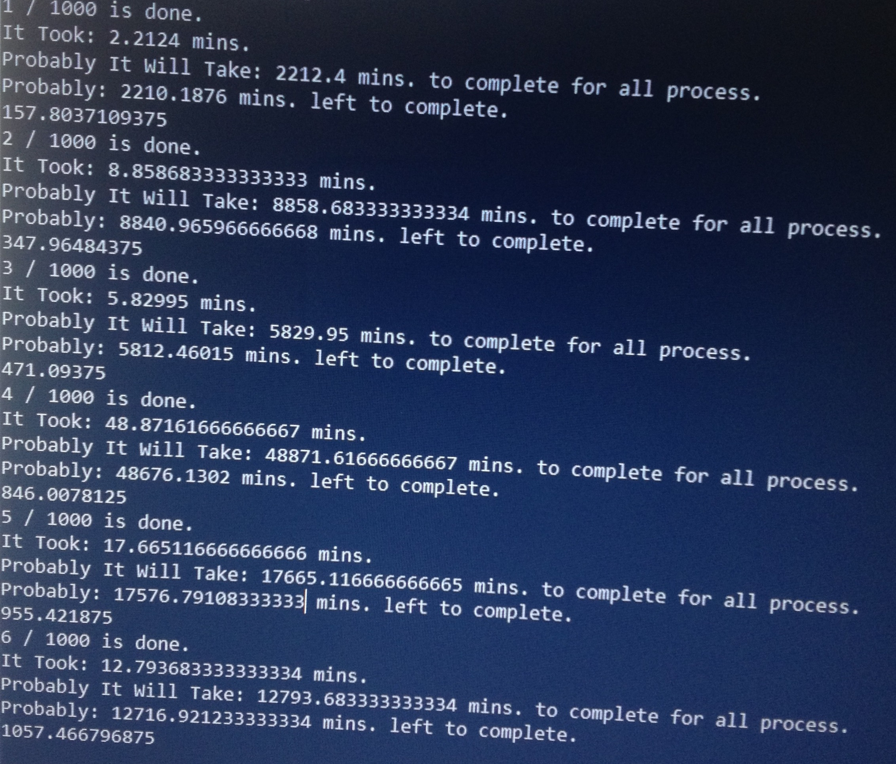

**Table 43:** Test Results#1

Here is first screen shot from the parser. It tooks too much time to parse data. Also, It has memory leaks. With this parser it will probably take more than 1 week.

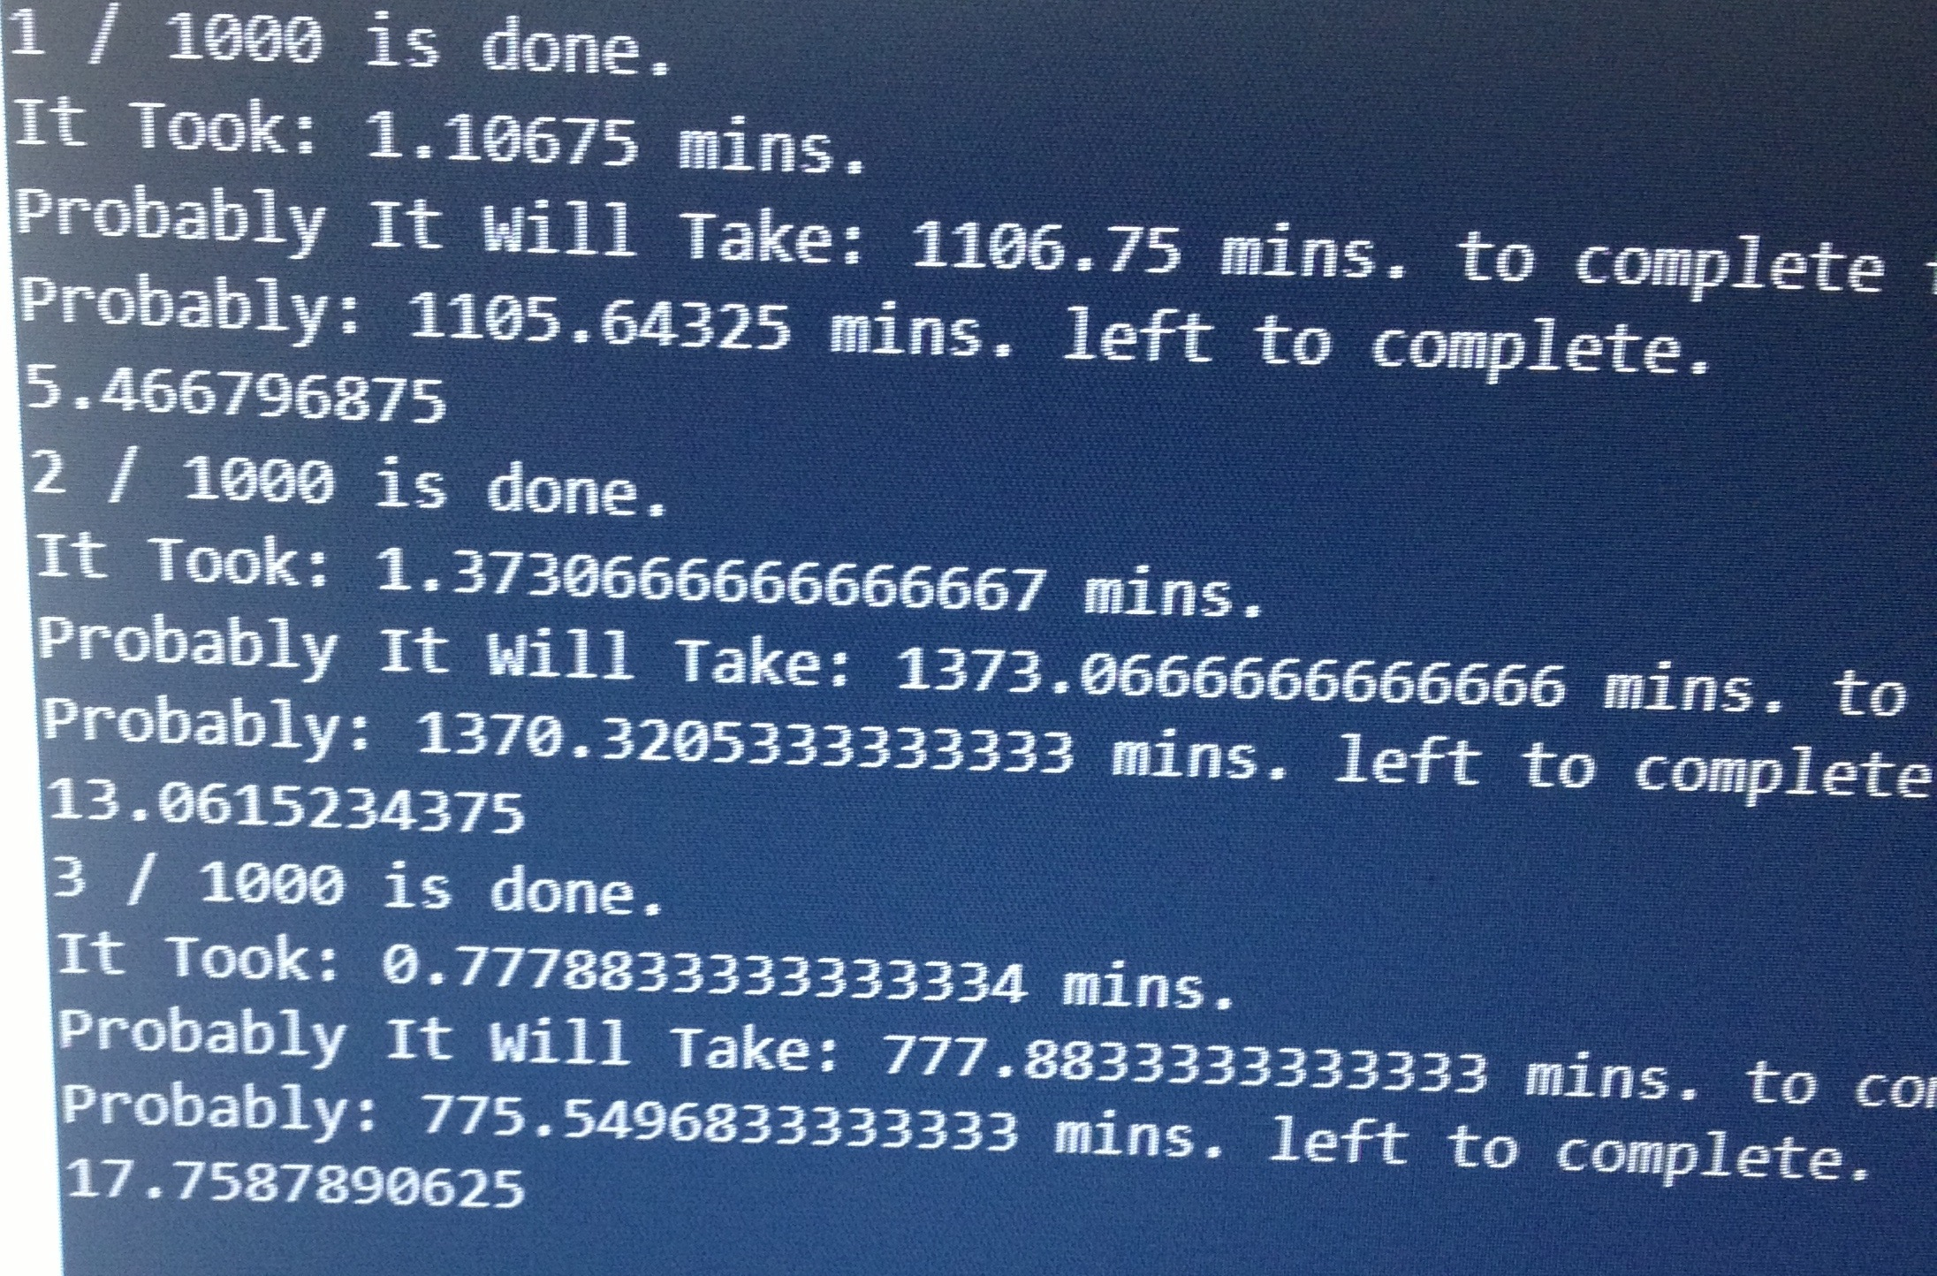

**Table 44:** Test Resuts#2

After some improvements and optizations on code it increased its speed dramatically. The error was too many insertion and controls on database and it takes too much time. However, memory leaks were still exists.

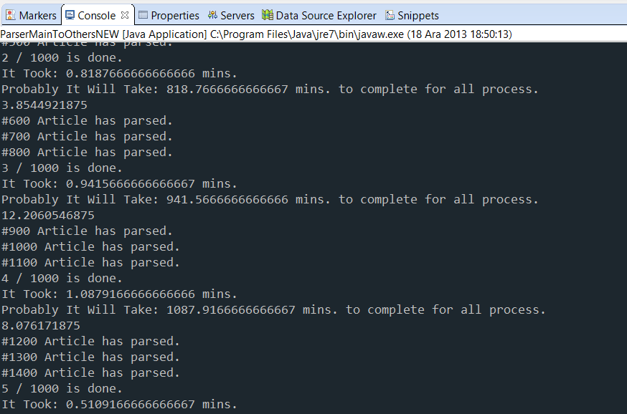

# Table 45: Test Results#3

After researched on the internet and changed my code a little bit I solved the memory leaks on the code and I used memory in my code so the database insertions and controlls have dropped. I created array for last added datas and kept their ID’s on array this way I used my computer’s memory more efficiently.

**Table 46:** Test Results#4

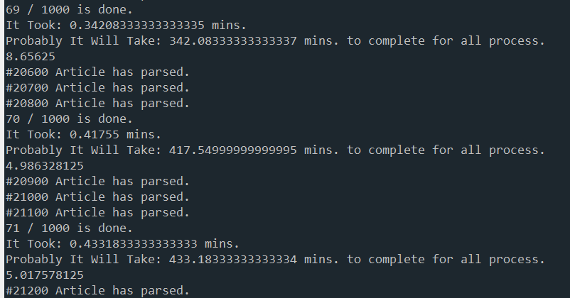

Here is final screen shot while my code doing its job. It now has the potential of parse 1 cycle under 1 minute. Some cycles can be done under 2 minutes but it’s because the information is little bigger than previous cycles. However, the code now time and memory efficient as I developed and improved it.

Now my code can parse the data under 15 hours. It was more than 1 week before the optimizations and improvements.

Information about screen shots:

There are performance improvements on java parser program. I designed this program to feedback me. It shows how much time took the 1 cycle (1/1000 means; total records/1000. 1 cycle almost equals 298 records). Some cycles have more info then previous or next cycle so some cyles took more time to complete. However, program has no memory leaks and it uses max 20MB RAM. From screen shots there is number without a label. That shows how much RAM does parser use.

# 8. Conclusion

In conclusion, this project represents many functions to the users in a good way. Especially, academicians, researchers and students can benefit for their researches. They can search topics, authors and in general addresses. In addition to search part, users can find the most popular areas and researchers. It helps them to find new areas to write an article and find researchers to work with who interested in these subjects or categories. And also it helps to get into touch other researchers and institutions easily. Users can plan their future career by analyze results.

Design of the database also provides the developer make new analysis and searches. Tables are very flexible to make relations between data and improve this project. Project has enough bases to make analysis and search for now but it can be developed for the future needs of users.

To sum up, this project represents new ideas about academic portals and gives a wide view about academic life all around the world. In this world that is constantly developing with increasing knowledge, this project is very useful and efficient to all users to reach academic information and data.

# 9. References

<http://thomsonreuters.com/web-of-science/>

<http://en.wikipedia.org/wiki/Software_design_document>

<http://www.postgresql.org/>

<http://www.oracle.com/index.html>

<http://www.eclipse.org/juno/>

<http://www.mysql.com/>

<http://stackoverflow.com/>

<http://www.postgresql.org/>

<http://www.w3schools.com/>

<http://www.apachefriends.org/en/xampp.html>

<http://www.wampserver.com/en/>

# 10. Lines-of-code Table

|  |  |  |  |  |  |
| --- | --- | --- | --- | --- | --- |
| **Module/Package** | Program | **Programmer(s) or the sources borrowed from** | **Purpose of the Program** | **Lines of Code Borrowed** | **Lines of Code Developed** |
| **Java (Parser)** | Logger.Java | Gokhan Guney | Keeps logs for the Parser.Java | 0 | 60 |
|  | Parser.Java | Gokhan Guney | Parse the 1 html file to the main table (version 1) | 0 | 167 |
|  | ParserNEW.Java | Gokhan Guney | Parse the 1 html file to the main table (final version) | 0 | 290 |
|  | ParserAll.Java | Gokhan Guney | Parse all the html files to the main table | 0 | 117 |
|  | Logger2.Java | Gokhan Guney | Keeps logs for the ParserMainToOther.Java | 0 | 60 |
|  | mainToReal.Java | Gokhan Guney | This program takes the needed columns from main table and inserts them to "real" | 0 | 150 |
|  | ParseMainToOther.Java | Gokhan Guney | This program takes needed information from "real" table and insert them to releated tables (version 1) | 0 | 644 |
|  | ParseMainToOtherNEW.Java | Gokhan Guney | This program takes needed information from "real" table and insert them to releated tables and makes correction on the data (final version) | 0 | 1077 |
| **CSS** | style.css | Gokhan Guney, Google | Style Sheet for the site. (GUI Design). Only Scroll bar style downloaded from internet | 42 | 1238 |
| **Java Script** | jquery1.8.1.js | Jquery | Jquery Library for Auto Complete Tasks | 9302 | 0 |
|  | js.js | Gokhan Guney, Google | This javascript program has few functions for auto complete tasks. Few lines gathered from google and developed top of them. | 10 | 40 |
| **PHP** | connect.php | Gokhan Guney | This program is used for connecting to the database. It has information for login process | 0 | 4 |
|  | getAnalyzeSuggestion.php | Gokhan Guney | This php has queries for auto complte tasks. This php is used in Analyze pages. | 0 | 56 |
|  | getSearchSuggestion.php | Gokhan Guney | This php has queries for auto complte tasks. This php is used in Search pages. | 0 | 50 |
|  | analyze.php | Gokhan Guney | Index page for analyze pages | 0 | 47 |
|  | analyzeAuthor.php | Gokhan Guney | 5 keywords for author names | 0 | 178 |
|  | analyzeAuthor2.php | Gokhan Guney | chart result fom analyzeAuthor.php | 0 | 186 |
|  | analyzeCategory.php | Gokhan Guney | 5 keywords for category names | 0 | 176 |
|  | analyzeCategory2.php | Gokhan Guney | chart result fom analyzeCategory.php | 0 | 187 |
|  | analyzeCity.php | Gokhan Guney | 5 keywords for city names | 0 | 176 |
|  | analyzeCity2.php | Gokhan Guney | chart result from analyzeCity.php | 0 | 184 |
|  | analyzeCountry.php | Gokhan Guney | 5 keywords for Countries | 0 | 178 |
|  | analyzeCountry2.php | Gokhan Guney | chart result from analyzeCountry.php | 0 | 184 |
|  | analyzeInstitution.php | Gokhan Guney | 5 keywords for Institution | 0 | 178 |
|  | analyzeInstitution2.php | Gokhan Guney | chart result from analyzeInstitution.php | 0 | 182 |
|  | analyzeSubject.php | Gokhan Guney | 5 keywords for subjects | 0 | 178 |
|  | analyzeSubject2.php | Gokhan Guney | chart result fom analyzeSubject.php | 0 | 184 |
|  | expertAuthor.php | Gokhan Guney | Subject search to find expert author on a chosen subject | 0 | 102 |
|  | expertAuthor2.php | Gokhan Guney | result from expertAuthor.php | 0 | 237 |
|  | expertDomain.php | Gokhan Guney | Subject search to find expert domain on a chosen subject | 0 | 102 |
|  | expertDomain2.php | Gokhan Guney | result from expertDomain.php | 0 | 239 |
|  | experts.php | Gokhan Guney | Index page for expert pages | 0 | 33 |
|  | index.php | Gokhan Guney | The main intro (index) page | 0 | 27 |
|  | navigatorMenu.php | Gokhan Guney | navigator Menu for Search pages | 0 | 15 |
|  | navigatorMenu2.php | Gokhan Guney | navigator Menu for Analyze Pages | 0 | 20 |
|  | navigatorMenu3.php | Gokhan Guney | navigator Menu for Top Lists Pages | 0 | 20 |
|  | navigatorMenu4.php | Gokhan Guney | navigator Menu for Expert Pages | 0 | 13 |
|  | parseMultiURL.php | Gokhan Guney | php program for parsing the url for analyze pages which have multi keywords for queries. | 0 | 75 |
|  | parseURL.php | Gokhan Guney, Google | php program for parsing the url for with one keyword. Substring and str replacement methods barrowed from php's site. | 1 | 33 |
|  | profileArticle.php | Gokhan Guney | Article page which has all essential information about article | 0 | 115 |
|  | profileAuthor.php | Gokhan Guney | Author profile page which has author's information, author's articles and author's co-authors | 0 | 309 |
|  | profileCategory.php | Gokhan Guney | Category profile page which has Category's articles. | 0 | 224 |
|  | profileInstitution.php | Gokhan Guney | Institution profile page which has Instition's essential information, Institution's authors and institution's articles | 0 | 279 |
|  | profileSubject.php | Gokhan Guney | Subject profile page which has references for a subject and articles on this subject | 0 | 233 |
|  | search.php | Gokhan Guney | Index page for search pages | 0 | 45 |
|  | searchAuthor.php | Gokhan Guney | 1 keyword input field for author name search | 0 | 101 |
|  | searchAuthor2.php | Gokhan Guney | shows the result from searchAuthor.php | 0 | 177 |
|  | searchCategory.php | Gokhan Guney | 1 keyword input field for category search | 0 | 101 |
|  | searchCategory2.php | Gokhan Guney | shows the result from searchCategory.php | 0 | 172 |
|  | searchCity.php | Gokhan Guney | 1 keyword input field for City Search | 0 | 99 |
|  | searchCity2.php | Gokhan Guney | shows the result from searchCity.php | 0 | 172 |
|  | searchCountry.php | Gokhan Guney | 1 keyword input field for Country search | 0 | 99 |
|  | searchCountry2.php | Gokhan Guney | shows the result from searchCountry2.php | 0 | 172 |
|  | searchInstitution.php | Gokhan Guney | 1 keyword input field for Institution search | 0 | 102 |
|  | searchInstitution2.php | Gokhan Guney | shows the result from searchInstitution.php | 0 | 180 |
|  | searchSubject.php | Gokhan Guney | 1 keyword input field for Subject search | 0 | 102 |
|  | searchSubject.2.php | Gokhan Guney | shows the result from searchSubject.php | 0 | 170 |
|  | topAuthors.php | Gokhan Guney | shows a list of authors who contributed most | 0 | 194 |
|  | topCategories.php | Gokhan Guney | shows a category list that’s ordered by total count of article | 0 | 174 |
|  | topCities.php | Gokhan Guney | shows a city list which ordered by total article count of the city | 0 | 173 |
|  | topCountries.php | Gokhan Guney | shows a city list which ordered by total article count of the country | 0 | 173 |
|  | topInstitutions.php | Gokhan Guney | shows a list of institutions which contributed most | 0 | 185 |
|  | tops.php | Gokhan Guney | Index page for top lists | 0 | 46 |
|  | topSubjects.php | Gokhan Guney | shows a subject list that's ordered by total count of article | 0 | 173 |

**Table 47**: Lines of codes